The Literary Society of Sivaji College, University of Delhi, is a platform for budding literary enthusiasts and writers to showcase and hone their literary skills. With a belief in freedom of all art forms, it is inclusive of diverse languages and genres of literature. We encourage students to enhance their knowledge and develop their literary craft through regular book discussions, poetry recitals sessions and film screenings and reviews.   
At its core our society is a place for literary wanderers to find acceptance as a community of people, who share a passion for Literary works. Our Annual Literary Fest- *Abhivyakti* is marked by inter- college quiz, creative writing and slam poetry competitions. The high point of the event is the conversation - *Guftugu*- with authors and poets where they unfold and share their journey and experience as writers.

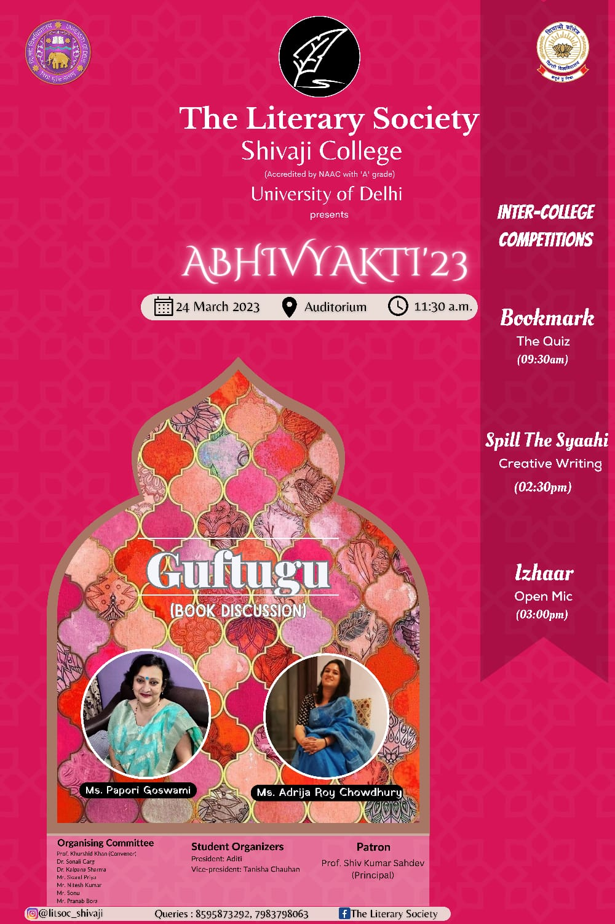 ***Abhivyakti ‘23***

***Abhivyakti* -** Annual Literary Fest

March 24, 2023.

**The fest comprised of four interactive events:**

**Bookmark: The Literary Quiz was** an inter-college competition. Six teams from various colleges of Delhi University participated in the event. The Quiz questions related to the Shakespearean era, Modern Indian and Foreign authors and their writings.

The quiz was a hit with the students who learnt about literature and literary persona in a fun and entertaining way.

**Guftugu: The Book Discussion with Authors**

Ms. Adrija Roychowdhury, author of *Delhi in Thy Name* (2021) and the noted Assamese translator Ms. Papori Goswami, the resource persons gave the audience a peek into the world of translations and books. They urged the audience to discover the world of books by becoming avid reader. Ms. Papori Goswami discussed the importance of knowing one’s language and continuously learning new things about other languages and cultures. She addressed the queries of the audience pertaining to her work and her approach to literary translations.

Ms. Adrija Roy chowdhary spoke about her debut book, *Delhi in Thy Name*. Many in the audience had read her book and thus an in-depth discussion ensued with the author. The audience were enamoured by the in-depth historical and cultural details of Delhi that her book threw light on. Ms. Adrija, responded to all the questions of the audience giving an insightful account of the history of Modern Delhi.

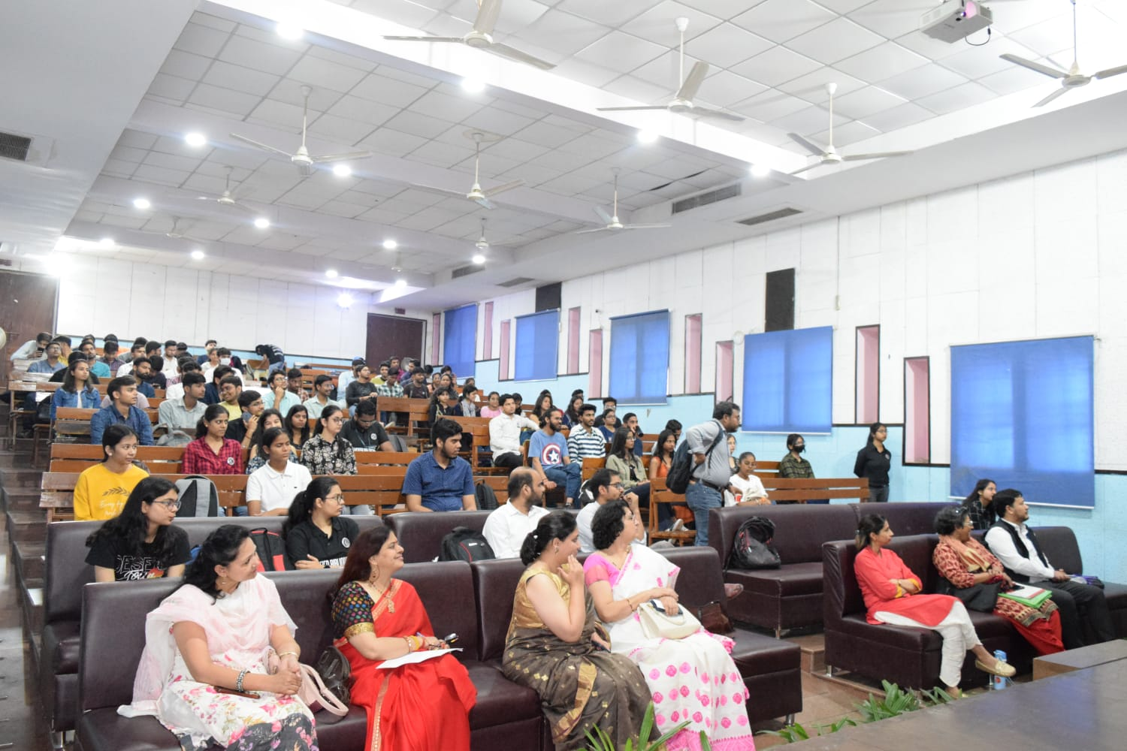

*The Guftugu* session

**Spill the Syaahi: The Creative Writing Competitio**n was the third attraction of the Literary Fest, where participants from colleges across Delhi University put their pen to creatively weave words into interesting stories and poetry with themes given to them in both Hindi and English.

**Izhaar: The Open Mic Competition** was the concluding event of the fest and its theme was "**Unafraid to Feel**. " A large number of students participated and unabashedly expressed their innermost feelings through their compositions.

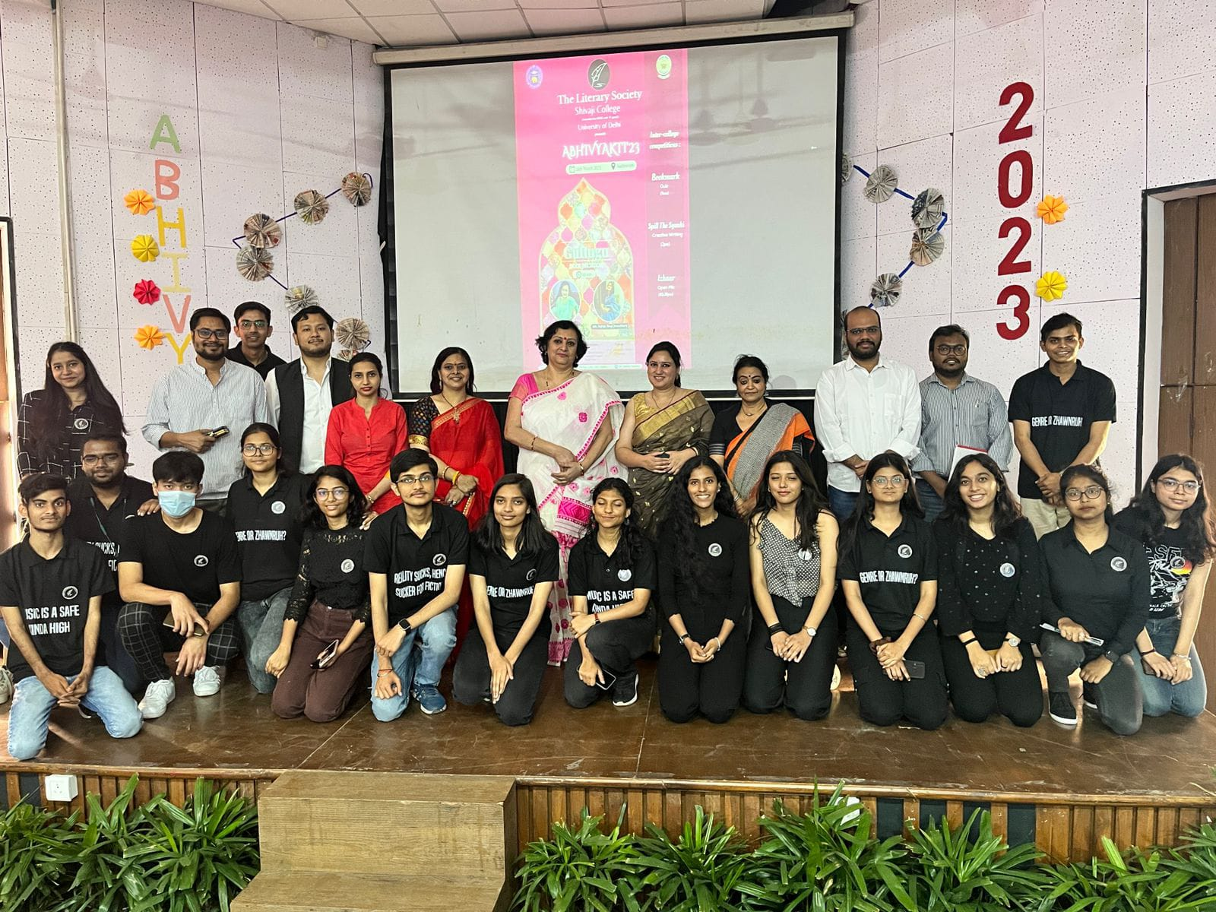  
Group Photo with the invited speakers

The Society also organized a Workshop on: **Storytelling through Photography March 20, 2023.**

The Resource Persons for the event were: Mr. Rahul Sharma-visual artist & photographer and Ms. Shilpa Sachdeva, writer, teacher and life skill educator. The students learnt the usage of photography to tell stories without words.

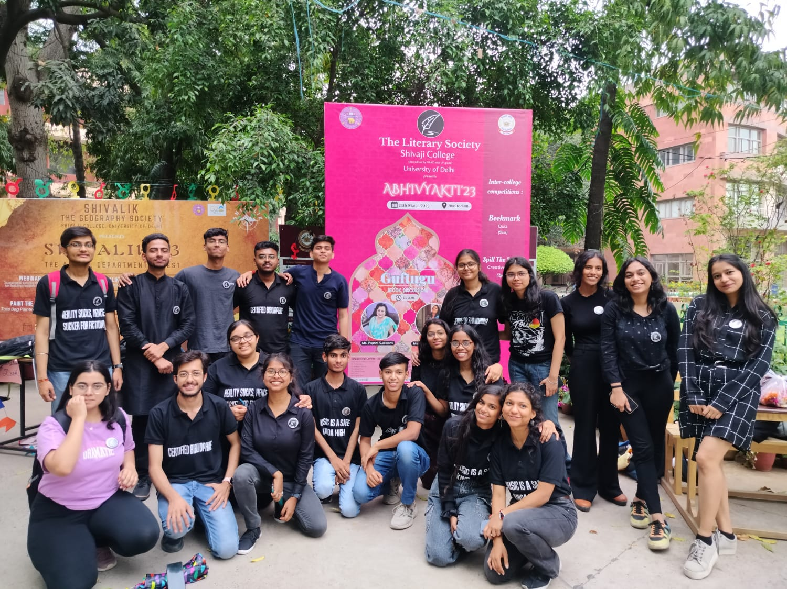

Student organisers of Abhivyakti ’23